Year 8 Science

2021

Narrogin Senior High School

Year 8 Science – 2021

Science Inquiry Skills (SIS only)

Questioning and predicting
Identify questions and problems that can be investigated scientifically and make predictions based on scientific knowledge (ACSIS139)
Elaborations
- considering whether investigation using available resources is possible when identifying questions or problems to investigate
- recognising that the solution of some questions and problems requires consideration of social, cultural, economic or moral aspects rather than or as well as scientific investigation
- using information and knowledge from their own investigations and secondary sources to predict the expected results from an investigation

Planning and conducting
Collaboratively and individually plan and conduct a range of investigation types, including fieldwork and experiments, ensuring safety and ethical guidelines are followed (ACSIS140)
Elaborations
- working collaboratively to decide how to best approach an investigation
- identifying any ethical considerations that may apply to the investigation
- taking into consideration all aspects of fair testing, available equipment and safe investigation when planning investigations
- collaborating with Aboriginal and Torres Strait Islander Peoples in the planning of scientific investigations, including considerations of heritage sites and artefacts

Measure and control variables, select equipment appropriate to the task and collect data with accuracy (ACSIS141)
Elaborations
- using specialised equipment to increase the accuracy of measurement within an investigation
- identifying and explaining the differences between controlled, dependent and independent variables

Processing and analysing data and information
Construct and use a range of representations, including graphs, keys and models to represent and analyse patterns or relationships in data using digital technologies as appropriate (ACSIS144)
Elaborations
- describing measures of central tendency and identifying outliers for quantitative data
- explaining the strengths and limitations of representations such as physical models, diagrams and simulations in terms of the attributes of systems included or not included

Summarise data, from students’ own investigations and secondary sources, and use scientific understanding to identify relationships and draw conclusions based on evidence (ACSIS145)
Elaborations
- constructing tables, graphs, keys and models to represent relationships and trends in collected data
- drawing conclusions based on a range of evidence including primary and secondary sources

Evaluating
Reflect on scientific investigations including evaluating the quality of the data collected, and identifying improvements (ACSIS146)
Elaborations
- suggesting improvements to investigation methods that would improve the accuracy of the data recorded
- discussing investigation methods with others to share ideas about the quality of the inquiry process

Use scientific knowledge and findings from investigations to evaluate claims based on evidence (ACSIS234)
Elaborations
- identifying the scientific evidence available to evaluate claims
- deciding whether or not to accept claims based on scientific evidence
- identifying where science has been used to make claims relating to products and practices
Communicating
Communicate ideas, findings and evidence based solutions to problems using scientific language, and representations, using digital technologies as appropriate (ACSIS148)
Elaborations
- using digital technologies to construct a range of text types to present science ideas
- selecting and using appropriate language and representations to communicate science ideas within a specified text type and for a specified audience

Science as a Human Endeavour:

NATURE AND DEVELOPMENT OF SCIENCE

Scientific knowledge has changed peoples’ understanding of the world and is refined as new evidence becomes available (ACSHE134)

Elaborations:
- investigating developments in the understanding of cells and how this knowledge has impacted on areas such as health and medicine
- discovering how people’s understanding of the nature of matter has changed over time as evidence for particle theory has become available through developments in technology
- considering how the idea of elements has developed over time as knowledge of the nature of matter has improved
- investigating the development of the microscope and the impact it has had on the understanding of cell functions and division

Science knowledge can develop through collaboration across the disciplines of science and the contributions of people from a range of cultures (ACSHE226)

Elaborations:
- investigating how knowledge of the location and extraction of mineral resources relies on expertise from across the disciplines of science
- considering how advances in technology, combined with scientific understanding of the functioning of body systems, has enabled medical science to replace or repair organs
- researching the use of reproductive technologies and how developments in this field rely on scientific knowledge from different areas of science
- investigating how Aboriginal and Torres Strait Islander Peoples connect knowledge from the disciplines of physics, chemistry, biology and geology in the development of material culture
- investigating how Aboriginal and Torres Strait Islander Peoples employ knowledge from the disciplines of chemistry, biology, physics and geology in their development of pigments and dyes

USE AND INFLUENCE OF SCIENCE

Solutions to contemporary issues that are found using science and technology, may impact on other areas of society and may involve ethical considerations (ACSHE135)

Elaborations:
- discussing ethical issues that arise from organ transplantation
- investigating requirements and the design of systems for collecting and recycling household waste
- investigating strategies implemented to maintain part of the local environment, such as bushland, a beach, a lake, a desert or a shoreline
- investigating how energy efficiency can reduce energy consumption
- investigating the development of vehicles over time, including the application of science to contemporary designs of solar-powered vehicles
- investigating use of sustainable technologies to deliver basic services in remote Aboriginal and Torres Strait Islander communities and considering ethical implications of these

People use science understanding and skills in their occupations and these have influenced the development of practices in areas of human activity (ACSHE136)

Elaborations:
- investigating the role of science in the development of technology important to the economies and communities of the Asia–Pacific regions, for example car manufacture, earthquake prediction and electronic optics
- recognising the role of knowledge of the environment and ecosystems in a number of occupations
- considering how engineers improve energy efficiency of a range of processes
- recognising the role of knowledge of cells and cell divisions in the area of disease treatment and control
- investigating how scientists have created new materials such as synthetic fibres, heat-resistant plastics and pharmaceuticals
- describing how technologies have been applied to modern farming techniques to improve yields and sustainability
- investigating how Aboriginal and Torres Strait Islander Peoples used scientific understandings of complex ecological relationships to develop specific fire based agricultural practices
- describing the impact of plant cloning techniques (asexual production) in agriculture such as horticulture, fruit production and vineyards

Biological sciences (BS1 and BS2)
BS 1: Cells are the basic units of living things; they have specialised structures and functions (ACSSU149)

Elaborations
- examining a variety of cells using a light microscope, by digital technology or by viewing a simulation
- distinguishing plant cells from animal or fungal cells
- identifying structures within cells and describing their function
- recognising that some organisms consist of a single cell
- recognising that cells reproduce via cell division
- describing mitosis as cell division for growth and repair
BS 2: Multi-cellular organisms contain systems of organs carrying out specialised functions that enable them to survive and reproduce (ACSSU150)

Elaborations
- identifying the organs and overall function of a system of a multicellular organism in supporting the life processes
- describing the structure of each organ in a system and relating its function to the overall function of the system
- examining the specialised cells and tissues involved in structure and function of particular organs
- comparing similar systems in different organisms such as digestive systems in herbivores and carnivores, respiratory systems in fish and mammals
- distinguishing between asexual and sexual reproduction
- comparing reproductive systems of organisms

Chemical sciences (CS1 and CS2)
CS 1: Properties of the different states of matter can be explained in terms of the motion and arrangement of particles (ACSSU151)

Elaborations
- explaining why a model for the structure of matter is needed
- modelling the arrangement of particles in solids, liquids and gases
- using the particle model to explain observed phenomena linking the energy of particles to temperature changes

Differences between elements, compounds and mixtures can be described at a particle level (ACSSU152)

Elaborations
- modelling the arrangement of particles in elements and compounds
- recognising that elements and simple compounds can be represented by symbols and formulas
- locating elements on the periodic table
CS 2: Chemical change involves substances reacting to form new substances (ACSSU225)
Elaborations
- identifying the differences between chemical and physical changes
- identifying evidence that a chemical change has taken place
- investigating simple reactions such as combining elements to make a compound
- recognising that the chemical properties of a substance, for example its flammability and ability to corrode, will affect its use
- investigating chemical reactions employed by Aboriginal and Torres Strait Islander Peoples in the production of substances such as quicklime, plaster, pigments, acids, salts and ethanol

Earth and space sciences (1 unit only)
ESS : Sedimentary, igneous and metamorphic rocks contain minerals and are formed by processes that occur within Earth over a variety of timescales (ACSSU153)

Elaborations
- representing the stages in the formation of igneous, metamorphic and sedimentary rocks, including indications of timescales involved
- identifying a range of common rock types using a key based on observable physical and chemical properties
- recognising that rocks are a collection of different minerals
- considering the role of forces and energy in the formation of different types of rocks and minerals
- recognising that some rocks and minerals, such as ores, provide valuable resources
- exploring the traditional geological knowledge of Aboriginal and Torres Strait Islander Peoples that is used in the selection of different rock types for different purposes

Physical sciences (PS 1 and PS 2)
PS 1: Energy appears in different forms, including movement (kinetic energy), heat and potential energy, and energy transformations and transfers cause change within systems (ACSSU155)

Elaborations
- recognising that kinetic energy is the energy possessed by moving bodies
- recognising that potential energy is stored energy, such as gravitational, chemical and elastic energy
- investigating different forms of energy in terms of the effects they cause, such as gravitational potential causing objects to fall and heat energy transferred between materials that have a different temperature
PS 2: Energy appears in different forms, including movement (kinetic energy), heat and potential energy, and energy transformations and transfers cause change within systems
Elaborations
- recognising that heat energy is often produced as a by-product of energy transfer, such as brakes on a car and light globes
- using flow diagrams to illustrate changes between different forms of energy
- investigating traditional fire-starting methods used by Aboriginal and Torres Strait Islander Peoples and their understanding of the transformation of energy

Year 8 Science 2021 Curriculum Program

Text Reference: Pearson Science 8 Student Book (2nd Edition)

Activity Book: Pearson Science 8 Activity Book (2nd Edition)

Term / Week | Curriculum | Learning Objectives | Text Reference | Activity Book Reference | Activities | Assessment (%)
T1 Wk 1 | TOPIC: Science Inquiry Skills (SIS)  -Getting to know you  -safety in the laboratory  -scientific equipment and diagrams
 | Questioning and predicting  Identify questions and problems that can be investigated scientifically and make predictions based on scientific knowledge:  Elaborations  - considering whether investigation using available resources is possible when identifying questions or problems to investigate  - recognising that the solution of some questions and problems requires consideration of social, cultural, economic or moral aspects rather than or as well as scientific investigation  - using information and knowledge from their own investigations and secondary sources to predict the expected results from an investigation | -recognise and order steps in the scientific method  -identify content included in each section of a lab report  -observation vs inference  -writing a hypothesis  -identifying research questions | Chapter 1 | 1.1  1.2  1.3 | Practice investigation: Bubbles
T1 Wk 2 | Planning and conducting  Collaboratively and individually plan and conduct a range of investigation types, including fieldwork and experiments, ensuring safety and ethical guidelines are followed.  Measure and control variables, select equipment appropriate to the task and collect data with accuracy:  Elaborations  - working collaboratively to decide how to best approach an investigation  - identifying any ethical considerations that may apply to the investigation  - taking into consideration all aspects of fair testing, available equipment and safe investigation when planning investigations  - using specialised equipment to increase the accuracy of measurement within an investigation  - identifying and explaining the differences between controlled, dependent and independent variables  - collaborating with Aboriginal and Torres Strait Islander Peoples in the planning of scientific investigations, including considerations of heritage sites and artefacts | -identify and label equipment, draw scientific diagrams  -dependent, independent, controlled variables  -accurate measurements and error  -identifying most accurate measuring equipment for particular tasks  -importance of repeat trials and calculating averages | Mod 1.4 | 1.4  1.5  1.6  1.8

T1 Wk 3 | Processing and analysing data and information  Construct and use a range of representations, including graphs, keys and models to represent and analyse patterns or relationships in data using digital technologies as appropriate.  Summarise data, from students’ own investigations and secondary sources, and use scientific understanding to identify relationships and draw conclusions based on evidence:  Elaborations  - describing measures of central tendency and identifying outliers for quantitative data  - explaining the strengths and limitations of representations such as physical models, diagrams and simulations in terms of the attributes of systems included or not included  - constructing tables, graphs, keys and models to represent relationships and trends in collected data  - drawing conclusions based on a range of evidence including primary and secondary sources | -recognise line graphs, column/bar graphs, histograms and pie charts and choose the most appropriate for a data set  -draw line and bar graphs accurately with appropriate headings, units, and titles  -quantitative vs qualitiatve data  -set up tables with appropriate headings, units, and titles  -identify outliers | Mod 1.1  Mod 1.2  Mod 1.3 | 1.7 |  | Task 1: Helicopter Investigation (4%)
T1 Wk 4 | Evaluating  Reflect on scientific investigations including evaluating the quality of the data collected, and identifying improvements.  Use scientific knowledge and findings from investigations to evaluate claims based on evidence:  Elaborations  - suggesting improvements to investigation methods that would improve the accuracy of the data recorded  - discussing investigation methods with others to share ideas about the quality of the inquiry process  - identifying the scientific evidence available to evaluate claims  - deciding whether or not to accept claims based on scientific evidence  - identifying where science has been used to make claims relating to products and practices  Communicating  Communicate ideas, findings and evidence based solutions to problems using scientific language, and representations, using digital technologies as appropriate (ACSIS148)  Elaborations  - using digital technologies to construct a range of text types to present science ideas  - selecting and using appropriate language and representations to communicate science ideas within a specified text type and for a specified audience | -identify possible reasons for inconsistencies in measurements |  | 1.9  Literacy review 1.10
T1 Wk 5 | Revision for Task 2. |  | Chapter review p.41 | 1.11 |  | Task 2: Investigating in Science Test (8%)

T1 Wk 6 | TOPIC: Biological Sciences 1 (BS 1)  Cells are the basic units of living things; they have specialised structures and function:  Elaborations  - examining a variety of cells using a light microscope, by digital technology or by viewing a simulation  ACSHE134:  - investigating developments in the understanding of cells and how this knowledge has impacted on areas such as health and medicine  - investigating the development of the microscope and the impact it has had on the understanding of cell functions and division | -Review characteristics of living things - MRS GREN  -Describe body organisation including systems, organs, tissues and cells  -identify relative size of cells  -Identify parts of a microscope | Chapter 2  Mod 2.1  2.4 | 2.1  2.2  2.4  2.5  2.6 | Microscope prac
T1 Wk 7 | Cells are the basic units of living things; they have specialised structures and function:  Elaborations  - distinguishing plant cells from animal or fungal cells  - identifying structures within cells and describing their function-photosynthesis and cellular respiration (word equations)  - recognising that some organisms consist of a single cell | -identify organelles in cells from diagrams and describe their function  -distinguishing plant, animal and fungal cells by presence or absence of particular organelles  -recognise that bacteria are single-celled organisms | Mod 2.2 | 2.3  2.7  2.8  2.9
T1 Wk 8 | Cells are the basic units of living things; they have specialised structures and function:  Elaborations  - recognising that cells reproduce via cell division  - describing mitosis as cell division for growth and repair | -mitosis makes identical daughter cells | Mod 2.3 | 2.10 |  | Task 3: Photosynthesis Investigation (4%)
T1 Wk 9 | ACSHE 136:  - recognising the role of knowledge of cells and cell divisions in the area of disease treatment and control  Overflow week for content and practical work |  |  | Literacy review 2.11
T2 Wk 1 | Revision for Task 4 |  | Chapter review p.87 | 2.12 |  | Task 4: Biology 1 Topic Test (9%)
Term Break

T2 Wk 2 | TOPIC: Chemical Sciences (CS)  Properties of the different states of matter can be explained in terms of the motion and arrangement of particles:  Elaborations  - explaining why a model for the structure of matter is needed  - modelling the arrangement of particles in solids, liquids and gases  ACSHE134: discovering how people’s understanding of the nature of matter has changed over time as evidence for particle theory has become available through developments in technology | -identify states of matter from diagrams  -explain the relative degree of movement of particles in different states  -recognise the particles do not change in size, there is more space between particles  -diffusion in liquids and gases | Year 7 Pearson review | 7.1  7.5 | Model particles as bodies in the room  PHET simulation states of matter
T2 Wk 3 | Properties of the different states of matter can be explained in terms of the motion and arrangement of particles:  Elaborations  - using the particle model to explain observed phenomena linking the energy of particles to temperature changes | -explain why increase in temperature leads to expansion  -describe temperature as the kinetic energy or speed that particles are moving |  | 7.6  7.7 | Demonstrations – heat and metal expanding
T2 Wk 4 | Differences between elements, compounds and mixtures can be described at a particle level:  Elaborations  - locating elements on the periodic table  - recognising that elements and simple compounds can be represented by symbols and formulas  ACHSE134: considering how the idea of elements has developed over time as knowledge of the nature of matter has improved | -Be able to recall and identify first 20 elements by their symbols  -recall formula of common chemical substances | Mod 6.1 | 6.2  6.3  6.4  Literacy review 6.9 | Plasticine – create compounds from atoms | Task 5: Elements Research and Presentation (7%)
T2 Wk 5 | Differences between elements, compounds and mixtures can be described at a particle level:  Elaborations  - modelling the arrangement of particles in elements and compounds | -identify elements, compounds and mixtures from diagrams | Mod 6.2 | 6.1  6.6
T2 Wk 6 | Overflow week for content and practical work.  Revision for Task 6 |  | Chapter review p.320 | 6.10 |  | Task 6: Chemistry Topic Test (9%)
T2 Wk 7 | TOPIC: Earth and Space Sciences (ESS)  Sedimentary, igneous and metamorphic rocks contain minerals and are formed by processes that occur within Earth over a variety of timescales:  Elaborations  - recognising that rocks are a collection of different minerals  - recognising that some rocks and minerals, such as ores, provide valuable resources  ACSHE226: investigating how knowledge of the location and extraction of mineral resources relies on expertise from across the disciplines of science | -describe ways in which we use natural resources such as ores  -recall three main types of rock and how they are formed  -visually represent the rock cycle as continuous – any rock can form another  -weathering vs erosion  -types of weathering | Mod 6.3  Mod 8.1 | 8.1  8.2  8.5 | Crayon rock cycle (clickview lessons)
T2 Wk 8 | Sedimentary, igneous and metamorphic rocks contain minerals and are formed by processes that occur within Earth over a variety of timescales:  Elaborations  - representing the stages in the formation of igneous, metamorphic and sedimentary rocks, including indications of timescales involved | IGNEOUS ROCKS  -describe relative sizes of crystals in intrusive and extrusive rock | Mod 8.2 | 8.6 | Rocks graphic organiser and videos | Task 7 Science Inquiry Crystal Investigation(4%)
T2 Wk 9 | Sedimentary, igneous and metamorphic rocks contain minerals and are formed by processes that occur within Earth over a variety of timescales:  Elaborations  - identifying a range of common rock types using a key based on observable physical and chemical properties | SEDIMENTARY ROCKS  -describe appearance of different types of sedimentary rock  -explain why fossils can only occur in sedimentary rock | Mod 8.3 | 8.3  8.4 | Sedimentary sandwiches (WASP)
T2 Wk 10 | - considering the role of forces and energy in the formation of different types of rocks and minerals | METAMORPHIC ROCKS  -give examples of metamorphic rocks and parent rocks  -list visible indicators of metamorphism and identify in rock samples | Mod 8.4 | 8.7
T2  Wk 11 | COUNTRY WEEK  - exploring the traditional geological knowledge of Aboriginal and Torres Strait Islander Peoples that is used in the selection of different rock types for different purposes |  | Chapter review p.364 | Literacy review 8.10 |  | Task 8: ESS Topic Test (9%)
Term Break
T3 Wk 1 | TOPIC: Physical Sciences (PS 1)  Energy appears in different forms, including movement (kinetic energy), heat and potential energy, and energy transformations and transfers cause change within systems:  Elaborations  - recognising that kinetic energy is the energy possessed by moving bodies  - recognising that potential energy is stored energy, such as gravitational, chemical and elastic energy | -list types of energy  -categorise energy as action or potential  -describe the relationship between kinetic and potential energy e.g when an object falls  -recognise conservation of energy and identify where energy can be ‘wasted’ | Chapter 5  Mod 5.1 | 5.2
T3 Wk 2 | Energy appears in different forms, including movement (kinetic energy), heat and potential energy, and energy transformations and transfers cause change within systems:  Elaborations  - investigating different forms of energy in terms of the effects they cause, such as gravitational potential causing objects to fall and heat energy transferred between materials that have a different temperature | -describe heat transfer as flow from high temperature to low temperature  -differentiate between heat and temperature  -explain how heat transfer occurs through conduction, convection and radiation |  |  |  | Task 9: Insulation Investigation (4%)
T3 Wk 3 | Energy appears in different forms, including movement (kinetic energy), heat and potential energy, and energy transformations and transfers cause change within systems  Elaborations  - using flow diagrams to illustrate changes between different forms of energy | -differentiate between energy transfer and transformation  -write energy flow diagrams  -describe which transfers occur in the generation of electricity e.g. using solar power or turbines |  | 5.4  5.5  5.6  5.7  5.8 | PHET energy transformations
T3 Wk 4 | Energy appears in different forms, including movement (kinetic energy), heat and potential energy, and energy transformations and transfers cause change within systems  Elaborations  - recognising that heat energy is often produced as a by-product of energy transfer, such as brakes on a car and light globes  - investigating traditional fire-starting methods used by Aboriginal and Torres Strait Islander Peoples and their understanding of the transformation of energy  ACSHE135:  - investigating how energy efficiency can reduce energy consumption Sustainability Cross-curriculum priority leaf icon  - investigating the development of vehicles over time, including the application of science to contemporary designs of solar-powered vehicles  Aboriginal Education/Activities  - Fire starting methods. Students use local materials to start a fire and discuss the science of the practice  Resources: http://www.aboriginalculture.com.au/fire-making.html  - Insulation properties of various local shelter materials. Students can design a project where they build a scale model of a shelter then test the insulation properties.  Resources: http://aboriginalculture.com.au/housing.html | -describe energy efficiency as the percentage of useful energy  -calculate energy efficiency in simple situations  -identify forms of waste energy in different situations | Mod 5.2
T3 Wk 5 |  |  |  |  |  | Task 10: Physics Topic Test (9%)

T3 Wk 6 | TOPIC: Biological Sciences 2 (BS 2)  Multi-cellular organisms contain systems of organs carrying out specialised functions that enable them to survive and reproduce:  Elaborations  - identifying the organs and overall function of a system of a multicellular organism in supporting the life processes  - describing the structure of each organ in a system and relating its function to the overall function of the system  - examining the specialised cells and tissues involved in structure and function of particular organs  Specific systems for this topic:  - Respiratory System  - Circulatory system  - Transport System in plants | -review body organisation  -give examples of specialised cells and tissues  -use microscopes to observe differences in specialised tissues | Chapter 2.4
T3 Wk 7 |  | RESPIRATORY SYSTEM  -label and explain the function of main organs  -explain how surface of alveoli help the function of gas exchange  -distinguish between respiration as breathing and the cellular process | Mod 3.2 |  | Demo - Model of the lung - balloons
T3 Wk 8 |  | CIRCULATORY SYSTEM  -describe how circulatory system works with respiratory to ensure oxygen is delivered around the body for respiration  -explain the difference between veins, arteries and capillaries  -label diagram of the heart | Mod 3.3 |  | Heart Dissection
T3 Wk 9 | Multi-cellular organisms contain systems of organs carrying out specialised functions that enable them to survive and reproduce:  Elaborations  - comparing similar systems in different organisms such as digestive systems in herbivores and carnivores, respiratory systems in fish and mammals  - Circulatory in Mammals vs. Transport System in plants | PLANT TRANSPORT  -list characteristics and functions of xylem and phloem | Jacaranda 2  Mod 8.4 |  | Celery prac
T3  Wk 10 | ACSHE226: considering how advances in technology, combined with scientific understanding of the functioning of body systems, has enabled medical science to replace or repair organs  ACSHE135: discussing ethical issues that arise from organ transplantation  Aboriginal Education/Activities  - How the aboriginal culture has a knowledge of the internal organs of the human body?  - 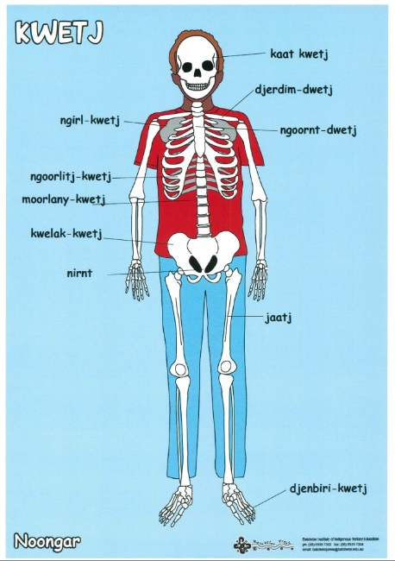  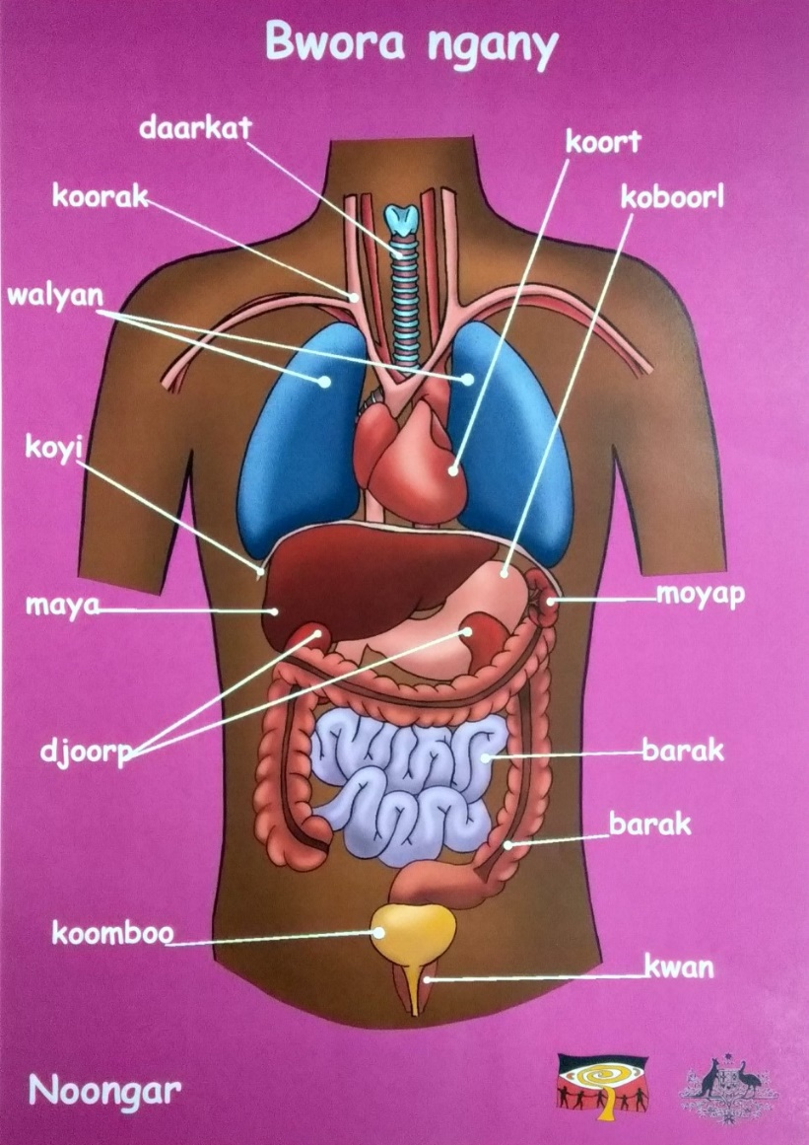 |  |  |  |  | Task 11:  Biological Systems Presentation Assignment (5%)
Term Break

T4 Wk 1 | Multi-cellular organisms contain systems of organs carrying out specialised functions that enable them to survive and reproduce:  Elaborations  - distinguishing between asexual and sexual reproduction (refer to mitosis) | -give examples of types or asexual reproduction  -Advantages and disadvantages of sexual and asexual reproduction | Mod 4.1 |  | Flower dissections
T4 Wk 2 | Multi-cellular organisms contain systems of organs carrying out specialised functions that enable them to survive and reproduce:  Elaborations  - comparing reproductive systems of organisms  ACSHE226: researching the use of reproductive technologies and how developments in this field rely on scientific knowledge from different areas of science  ACSHE136: describing the impact of plant cloning techniques (asexual production) in agriculture such as horticulture, fruit production and vineyards | -explain how sexual reproduction in plants requires pollination – compare to mammals  -label diagrams of flowers and describe the role of each part in sexual reproduction | Mod 4.2
T4 Wk 3 | Aboriginal Education/Activities  - Traditional aboriginal health care methods and how they link closely to modern techniques. Dealing with respiratory and circulatory complications. Students create poster outlining the effectiveness and science of local bush medicine.  - Distilling essential oils eg: eucalyptus  Resources:  https://www.naturalhealthmag.com.au/nourish/australian-bush-medicine  http://www.bushmedicine.ws/ |  |  |  |  | Task 12: Biology 2 Topic Test (9%)
T4 Wk 4 | TOPIC: Chemical Sciences (CS 2)  Chemical change involves substances reacting to form new substances  Elaborations  - identifying the differences between chemical and physical changes | -give examples of physical and chemical change  -describe chemical change as atoms rearranging and new substances formed | Mod 7.1 | 7.1  7.2
T4 Wk 5 | - identifying evidence that a chemical change has taken place | -list evidence of chemical change  -identify reactants and products  -write word equations  -identify common chemical reactions – photosynthesis, respiration, rusting, combustion | Mod 7.2  Mod 7.3 | 7.3  7.9
T4 Wk 6 | - investigating chemical reactions employed by Aboriginal and Torres Strait Islander Peoples in the production of substances such as quicklime, plaster, pigments, acids, salts and ethanol  ACSHE135: investigating requirements and the design of systems for collecting and recycling household waste  ACSHE136:  - investigating how scientists have created new materials such as synthetic fibres, heat-resistant plastics and pharmaceuticals
T4 Wk 7 |  |  |  | Literacy review 7.10 |  | Task 13: Chemistry 2 Topic Test (8%)
T4 Wk 8-10 | STEM Challenge
 | End of 2021 Planner

